 | October University for Modern Sciences and Arts  (MSA)  Department of Computer Systems Engineering  Course: ECE 264 / ESE 152 Digital Logic Design II  Instructors: Prof. Fawzy Ibrahim and Dr. Farah Raad

October University for Modern Sciences and Arts (MSA)
Electronic and Communication Department
Project Title Design and Implementation of
Traffic Light Project Description

Term Project for ECE264/CSE152 Digital Logic Design II

Elaborated By:

Name: Youssef Hossameldeen ID:245095
Name: Adham Ahmed Hassan ID:246093
Name: zeyad Ashraf ID:248643

Supervised by:

Instructors: Prof. Fawzy Ibrahim and Dr. Farah Raad

TAs: Eng. Shahenda M. Shokry, Eng. Abdelrahman Adam and Eng. Mohamed Salah

Traffic Light Project Description

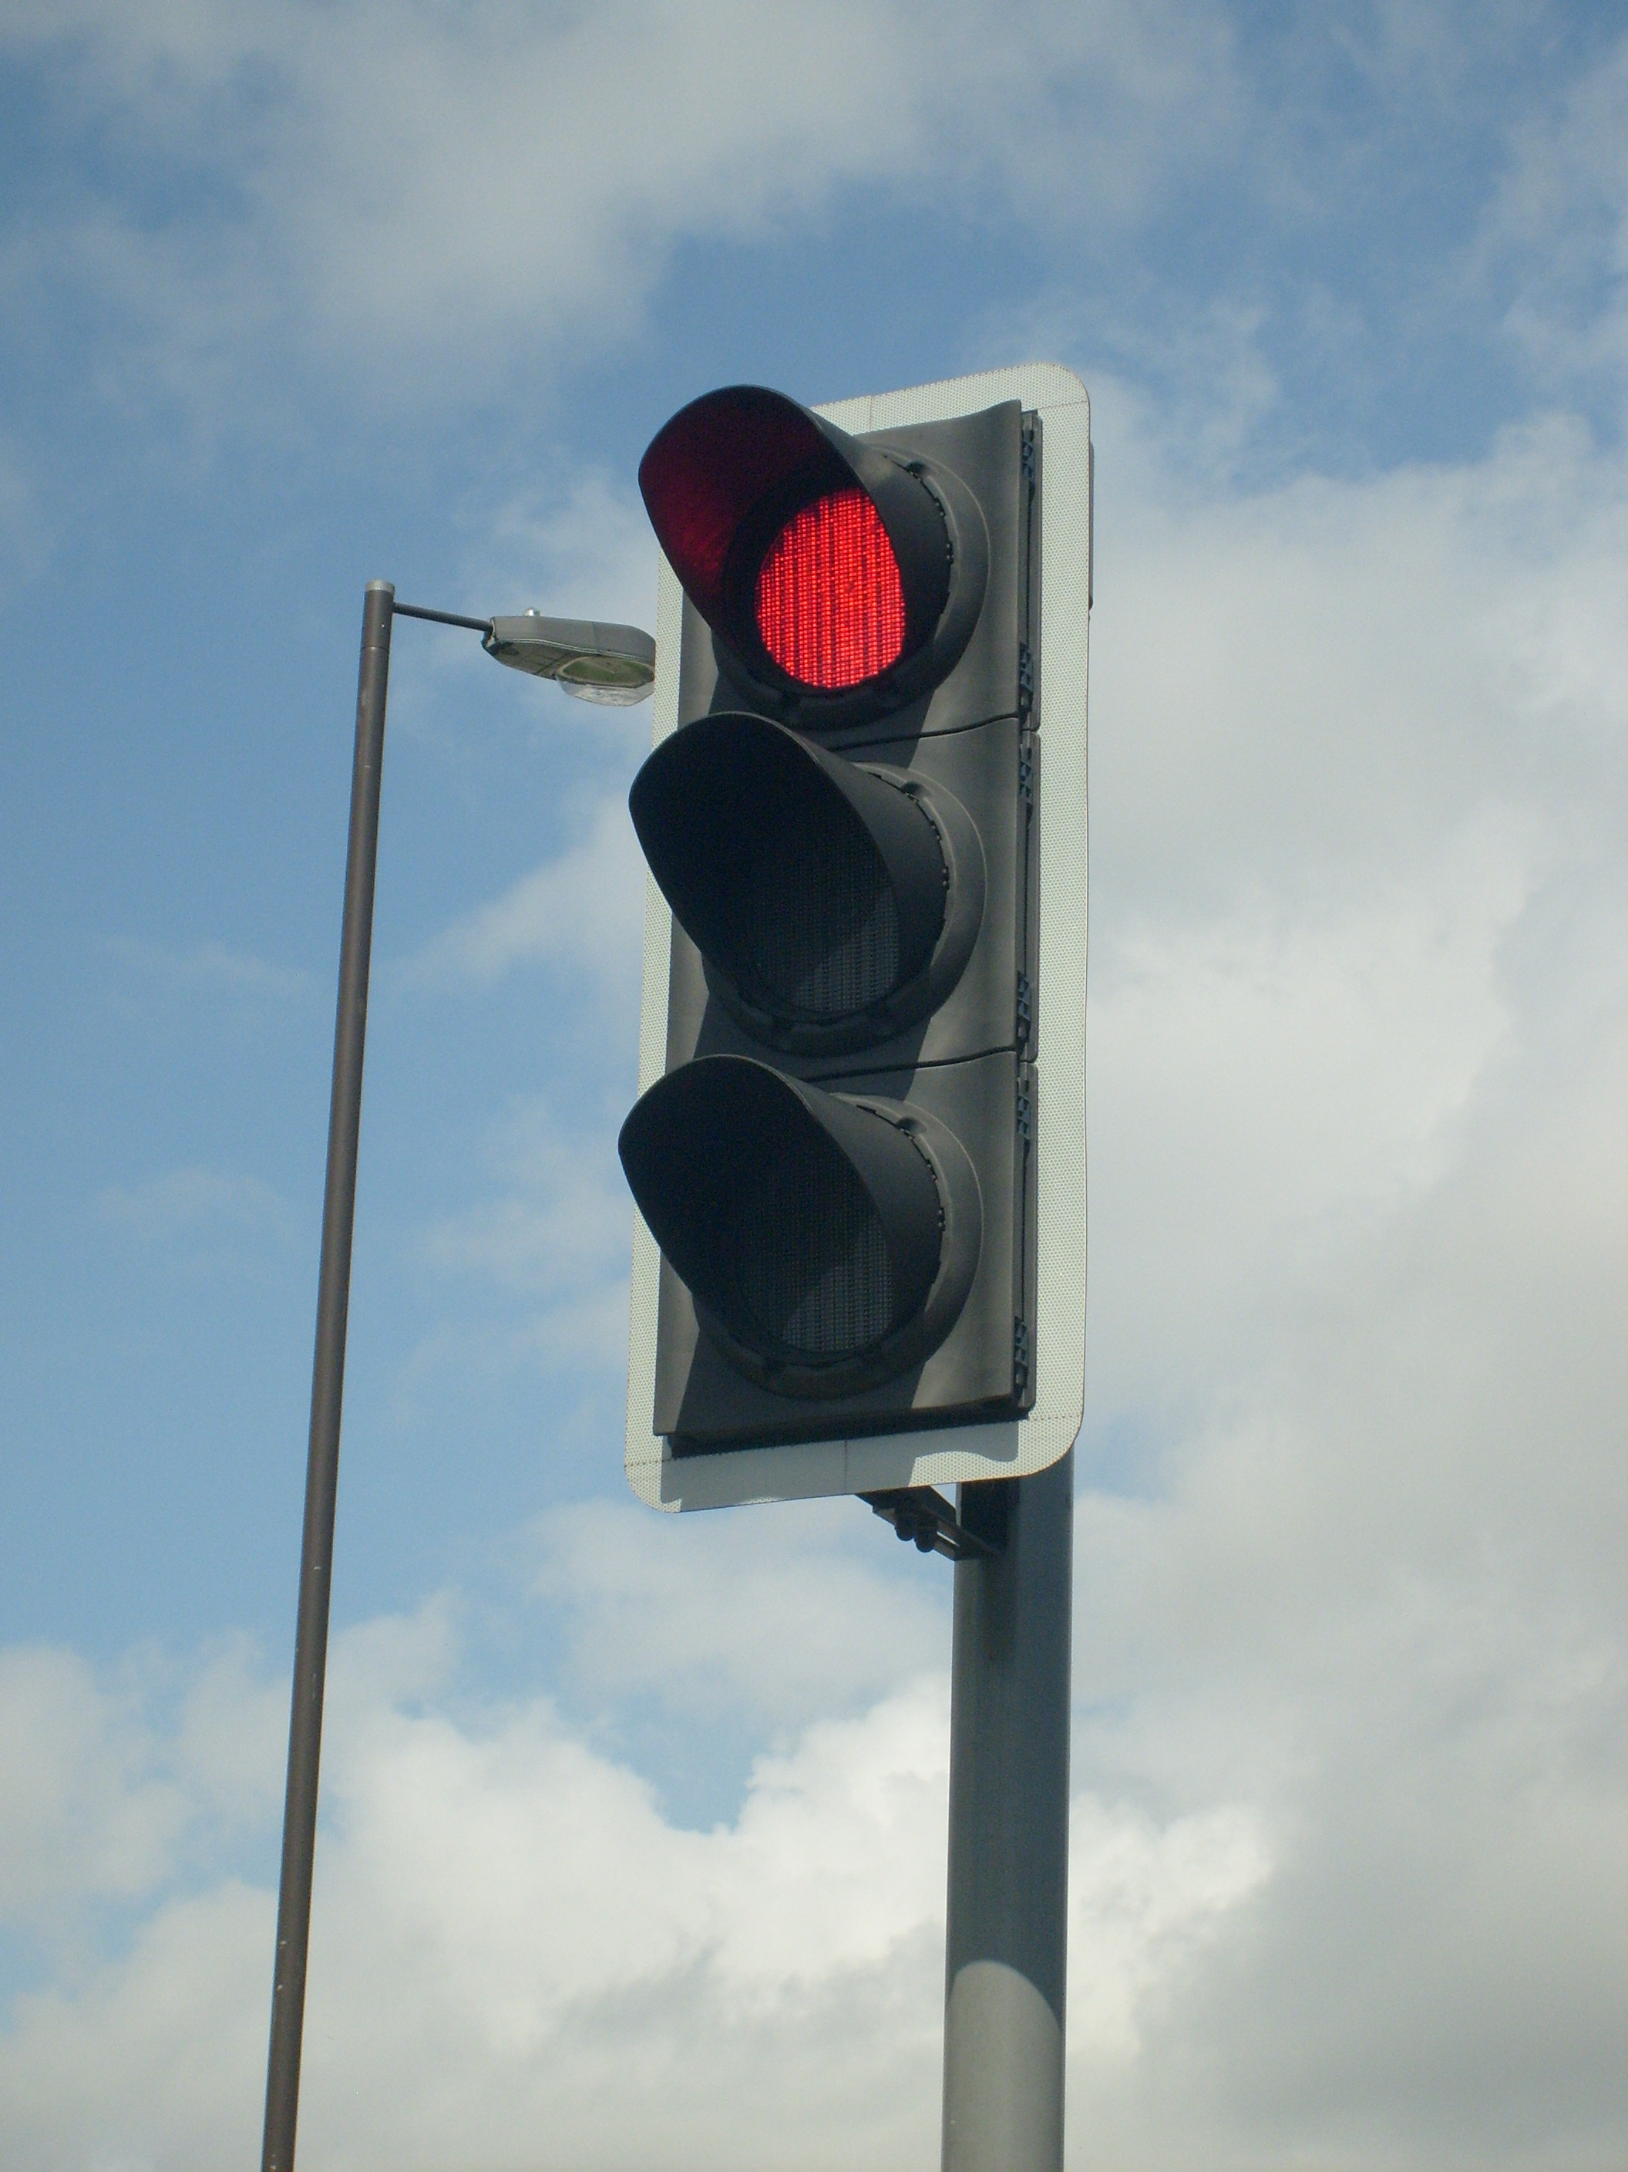
Introduction to Traffic Light Systems:
This report presents the design and implementation of a digital traffic light controller system using combinational and sequential logic components. The primary objective of this project is to simulate a realistic traffic signal sequence that operates on a defined time cycle: 30 seconds for the green light, 2 seconds for the yellow light, and 30 seconds for the red light. The system is built using fundamental digital components, including a 555 timer, synchronous BCD counters (74190), logic gates, and display drivers, to demonstrate how digital logic can be used to model time-based state transitions.

Components:

here are the components of the traffic light controller system detailed in report:

- 555 Timer IC x1
- 74190 Synchronous Up/Down Counter Logic Gates x2
- T Flip-Flops (implemented using J-K flip-flops) x1
- 7448 7-segment decoder x2
- 7400 (2 inputs NAND gate) X1
- 7432 (2 inputs OR gate) x1
- 4073 (3 inputs OR gate) x1
- 4072 (4 inputs OR gate) x1
- 7404 not gates X1
- 7408 and gates X1
- Resistance (47k – 10k – 1k – 100) ohms
- Capacitors (10u – 10n) farads
- 7-segment common cathode x2
- Traffic light module x1

Project Overview:
- Timer 555
The 555 Timer IC is widely used for generating clock pulses in digital circuits. When configured in astable mode, it operates as a free-running oscillator, continuously producing a square wave output by alternately charging and discharging an external capacitor through two resistors, R1 and R2.
To generate a 1 Hz clock signal (i.e., one pulse per second), the timing components must be carefully selected based on the standard frequency formula for the 555 timer in astable mode:
$$f=\frac{1}{T}=\frac{1.44}{\left(R1+2R2\right)C}$$

Simplifying the Design
For simplicity and symmetry in timing, we can assume:
- $R1 = R2 = R$
- $C=10 μF=10×{10}^{-6} F$
- Desired frequency$f=1 Hz$
Substituting these values into the equation:
$$f=\frac{1.44}{\left(3R\right)×10×{10}^{-6}}$$
And the frequency we want is 1Hz
$$R=\frac{1.44}{3 ×{10}^{-5}}=48.1kΩ$$

- Up/Down BCD Counters (U1, U2) 74190

- Cascading connection of two 74190 counters:
the cascaded connection of two 74190 decade counters to achieve a count up to 99, the clock signal is applied to the Clock Pulse (CP) input of the least significant counter (units). The Ripple Clock Output (RCO) of the units counter is then connected to the Clock Pulse (CP) input of the most significant counter (tens), enabling the tens counter to increment on the carry-out from the units counter. The Up/Down (U/D) control inputs of both counters are tied together to define the counting direction. The Count Enable (CE') inputs are typically held at a logic low to permit continuous counting. The Parallel Load (PL') inputs should be held at a logic high to disable asynchronous loading during normal operation. The BCD outputs (Q0-Q3) of each counter represent the units and tens digits of the count.

- Basic 74190 pins:
- Enable (pin 4) connected to ground
- $PL$ (pin 11) connected to ground to load a number to start counting from.
- Clk (pin 14) connected to the timer 555.
- Gnd (pin 8)
- Vcc (pin 16)

- Sequence of Loaded Values:
You stated that the counter loads the following values in sequence:
- First value: 0000 0010 (binary, which is 2 in decimal), yellow light.
- Second value: 0011 0000 (binary, which is 30 in decimal), red light
- Third value: 0011 0000 (binary, which is 30 in decimal), green light.

- Counter Data Input Connections (MSD and LSD counters):
For the MSD counter:
Cases | D0 | D1 | D2 | D3
Case 1 | 0 | 0 | 0 | 0
Case 2 | 0 | 0 | 1 | 1
Case3 | 0 | 0 | 1 | 1

The signals Q0 and Q1 consistently remain at a logic level of zero. In contrast, the signals Q2 and Q3 cycle through a sequence 0 1 1.

For the LSD counter:
Cases | D0 | D1 | D2 | D3
Case 1 | 0 | 0 | 1 | 0
Case 2 | 0 | 0 | 0 | 0
Case3 | 0 | 0 | 0 | 0

The signals Q0, Q1 and Q3 consistently remain at a logic level of zero. In contrast, the signals Q2 cycle through a sequence 1 0 0.
To generate the repeating output sequence 0 → 1 → 1, we implement a T flip-flop using a standard JK flip-flop configuration. This setup toggles the output on each rising clock edge, allowing us to produce a signal (Z) that follows the required pattern. By properly wiring the JK flip-flop in toggle mode (J = K), the output transitions are controlled in a way that repeats the “011” pattern with each clock pulse. This output (Z) is then used to determine which preset value is loaded into the counter at specific intervals.

Before implementing the circuit, we construct a state table to define the behavior of the system and verify that the correct output sequence , Ta and Tb flip-flop inputs:
 | Present state |  | Next state |  | Flip flop inputs |  | output | Traffic lights
Cases | QB | QA | QB | QA | TB | TA | Z | yellow | red | green
Case 1 | 0 | 0 | 0 | 1 | 0 | 1 | 0 | 1 | 0 | 0
Case 2 | 0 | 1 | 1 | 0 | 1 | 1 | 1 | 0 | 1 | 0
Case 3 | 1 | 0 | 0 | 0 | 1 | 0 | 1 | 0 | 0 | 1
_ | 1 | 1 | x | x | x | x | x | x | x | x

We will deduce the equations of Tb, Ta and the output Z using k-maps

Tb
0 | 1
1 | x
T_{b} = Q_{a} + Q_{b}

Z
0 | 1
1 | x
z = Q_{a} + Q_{b}

Yellow
1 | 0
0 | x
Y = Q`_{a} * Q`_{b}

Ta
1 | 1
0 | x
T_{a} = Q `_{b}

Red
0 | 1
0 | x
R = Q_{a}

Green
0 | 0
1 | x
G = Q_{b}
- Zero indicator
For a 74190 up/down decade counter, a "zero indicator" is crucial to determine when the count has reached its minimum. This signal is essential for interfacing with other digital components, such as a Parallel Load input, to initiate a reset or other synchronous actions when the counter cycles back to zero.

We will rely on the zero indicator from both the Most Significant Digit (MSD) and Least Significant Digit (LSD) counters. The instant the counters pass the "00" state (meaning they were at 00 and are about to increment), we will trigger a reset, effectively resetting them when they reach "99" (the state just before 00 in an up-counting sequence if they were to wrap around from 99).

MSD COUNTER (B) |  |  |  | LSD COUNTER (A) |  |  |  | OUTPUT Z
Q0 | Q1 | Q2 | Q3 | Q0 | Q1 | Q2 | Q3 | Y
1 | 0 | 0 | 1 | 1 | 0 | 0 | 1 | 0  (because the PL is active low)

$$Y= \overline{\left\{\overline{Q_{b0}}⋅Qb1 ⋅Qb2 ⋅\overline{Q_{b3}}⋅\overline{Q_{a0}}⋅Qa1 ⋅Qa2 ⋅\overline{Q_{a3}}\right\}}$$

In this only case the output will be zero which will reset the counter from the PL(pin 11)

- 7448 BCD to 7-Segment Decoders (MSB and LSB Displays)
The system uses two 7448 BCD to 7-segment decoder ICs to convert binary-coded decimal (BCD) outputs into visual numeric digits on common cathode 7-segment displays.

Function of the 7448 Decoder:
- Accepts a 4-bit BCD input (0000 to 1001).
- Activates the appropriate combination of segments (a–g) to display the corresponding decimal digit (0–9).
- Specifically designed to drive common cathode 7-segment displays.

Decoder Assignments in the Circuit

Decoder Connected to MSB Counter 2:
- Receives BCD input from the most significant digit (MSB) counter.
- This counter represents the tens digit of the countdown and cycles through values like 3 to 0 (or 2 to 0 during yellow phase).
- The decoder translates this BCD input into the correct numeric digit on the display.
- Example: BCD input 0011 from counter 2 results in displaying the digit "3".

Decoder Connected to LSB Counter 1:
- Takes BCD input from the least significant digit (LSB) counter.
- This counter tracks the units digit, cycling through values 9 to 0.
- The connected decoder processes this input and displays the corresponding digit.
- Example: BCD input 0100 from counter 1 results in the digit "4" being shown.

Summary
- The MSB decoder shows the tens place of the countdown.
- The LSB decoder displays the units place.
- Combined, they present a clear, real-time two-digit countdown (e.g., 30, 29, ..., 00) for the traffic light timing sequence.

Project objectives:
The main objectives of this project are as follows:
- To design a digital traffic light controller that simulates a standard signal sequence using logic components.
- To implement precise timing intervals for each light phase:
  - Green light: 30 seconds
  - Yellow light: 2 seconds
  - Red light: 30 seconds
- To utilize basic digital electronics components, such as the 555 timer, BCD counters (74190), logic gates, flip-flops, and 7-segment display drivers, to construct a functional and reliable timing system.
- To display the countdown time for each signal phase using dual 7-segment displays driven by BCD-to-7-segment decoders (7448).
- To develop and simulate the complete system using circuit simulation software (e.g., Proteus) to verify logical correctness and performance.
- To demonstrate the integration of combinational and sequential logic in controlling time-dependent outputs (traffic lights) based on counting states.

EQUATIONS:

Fig.2. traffic light project

References:

